**2 Final ideas for development**

**IOT Psychotropic home art**An interface for the house related to the psychotropic house and the umwelt. A home art piece connected to the internet and influenced by the home occupants, either individually or as a collective. The art would be influenced by; biometric sensors such as temperature, pulse, muscle, co2, fingerprint or neuro sensors worn by the occupants. Other sensing techniques could be pressure, capacitive touch, vibration, sound or camera. The idea behind the psychotropic house is that the previous occupant will be left behind and remain a part of the house for a long time until they are eventually overwritten.

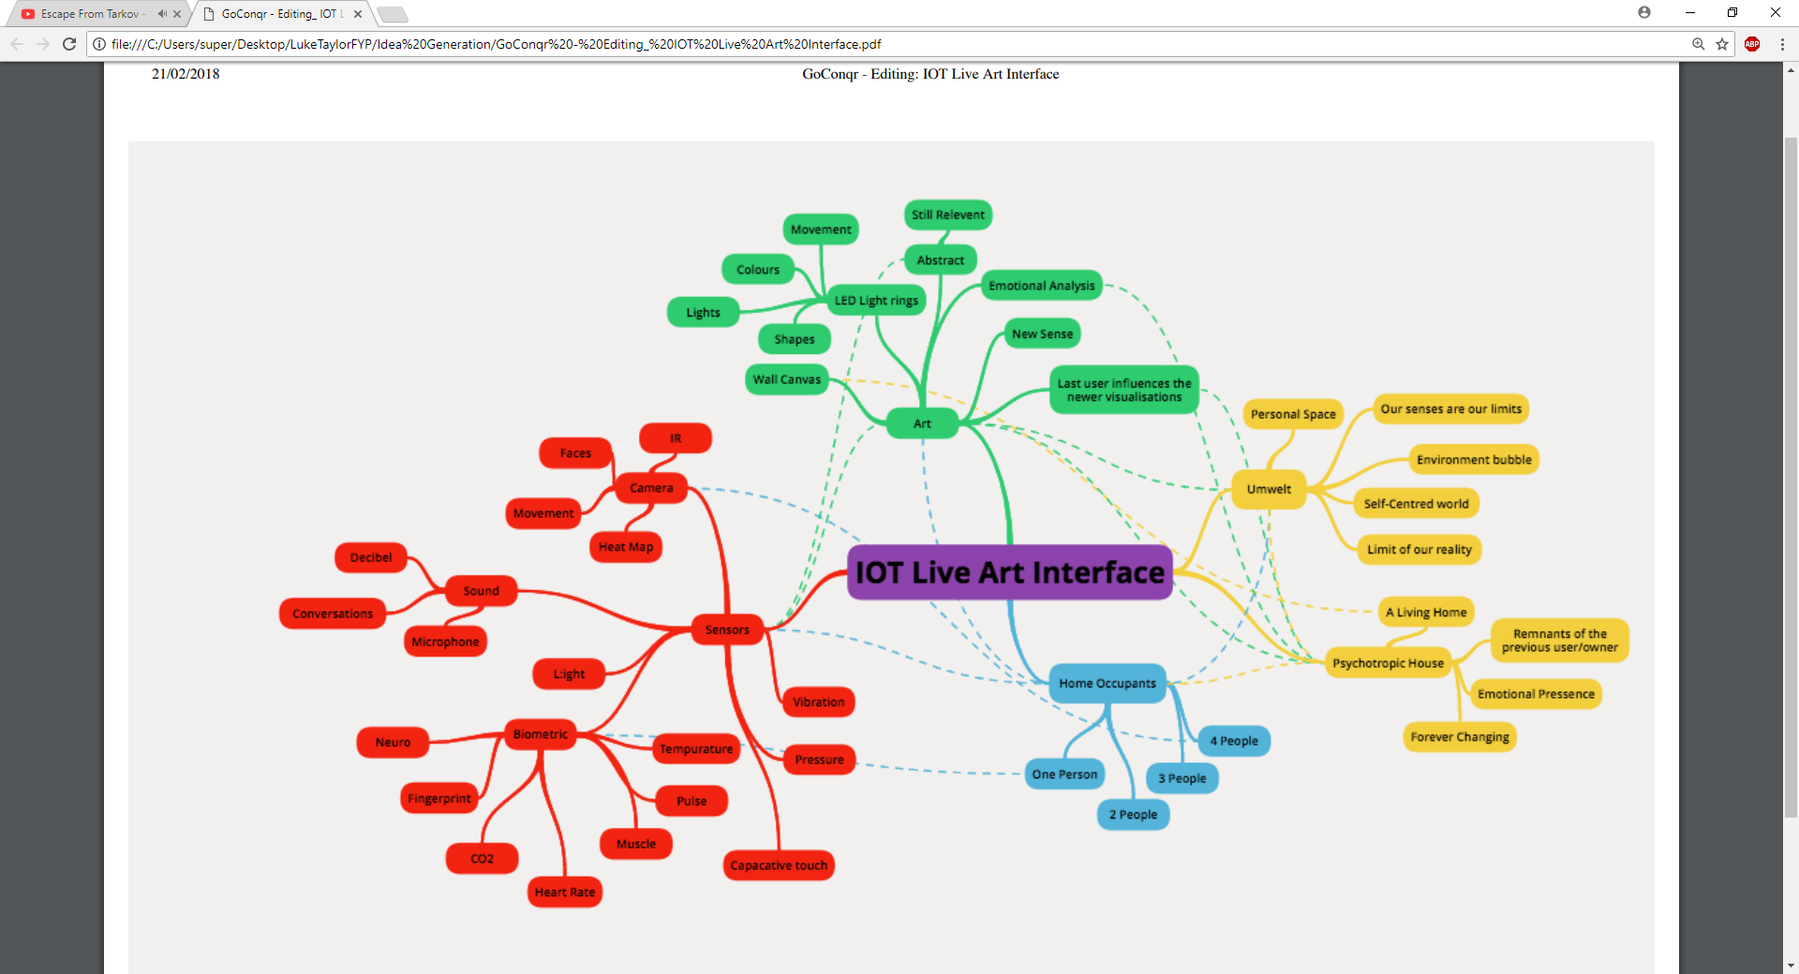

The art needs to express the data taken from the home occupants. I feel this may be better done in a more abstract way, so the user can make what they want out of the data instead of giving it obvious hard pre-sets. This will also allow for some inaccuracy in the data. I think as part of the theme is psychotropic the artwork could be based on an emotional analysis, or because the umwelt is also an inspiration it could be an enabler for a new sense to improve our umwelt. The art could be different for each person looking at it (facial recognition or similar).

**Umwelt Peripheral extensions**An IOT based wearable inspired by the Umwelt. The Umwelt is a German word for “environment” or “surroundings” and is formed from the biological study of communication and signification in humans and animals. The phrase often translates to “self-centred world” and is used to describe the fact that every human and animal throughout the animal kingdom will pick up on different environmental signals within the same eco-system. What’s most interesting about this is that we cannot get past our own umwelt that we have been set in since day one and we accept that this is the limit of our reality and that there is nothing more for us. However, these other signals are out there and available to us we just can’t access them with the sensors we are equipped with. With the use of the IOT and modern sensor technology I would like to build a wearable peripheral device that will expand our Umwelt and change the way we live as humans. This is something that’s started a long time ago, things like hearing aids eye implants are an early Implementation this is known as sensory substitution and is great as an aid for people who have had a part of their umwelt missing or taken from them such as deaf or blind people.